Group: GymRatz (#4-1)

Members: Cory Rooker, Cameron Blount, Styllez Ferguson, Joshua Welborn

Project Milestone 10-2

Part 1:

* User names, emails, and body stats will be recorded.
* Workouts are tracked.
* User created workouts are stored.
* User profile pictures
* User comments

To guard user data, it should all be stored in an encrypted manner and if possible locally. Otherwise this data could be stolen and misused. Profile pictures could be integrated through a third-party API like gravatar. This would allow the pictures to be safely checked and uploaded and guards inappropriate content. Finally, if users are able to see other user’s stats then make sure that users can select which data they can share. Some kind of moderator needs to also be added to watch the user comments.

Part II:

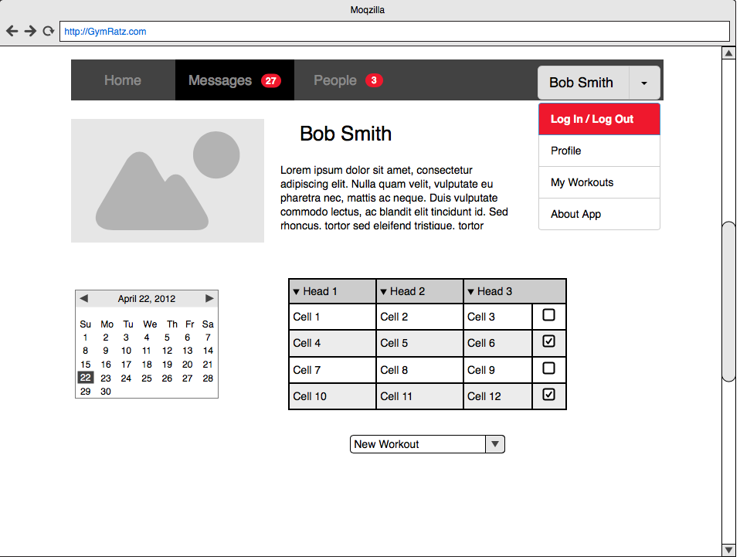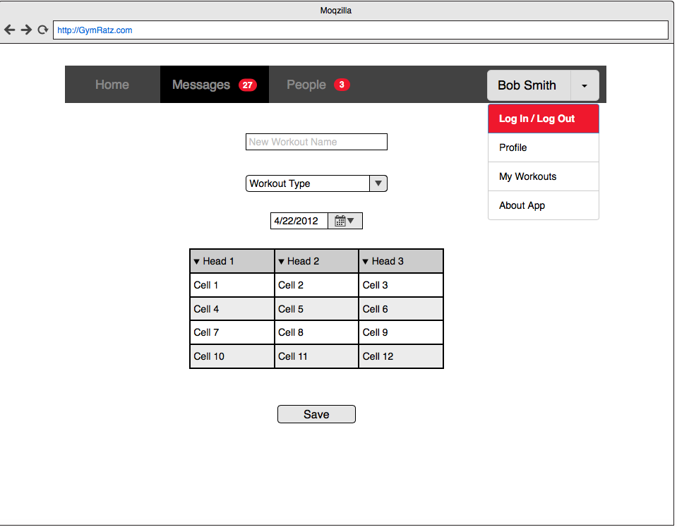

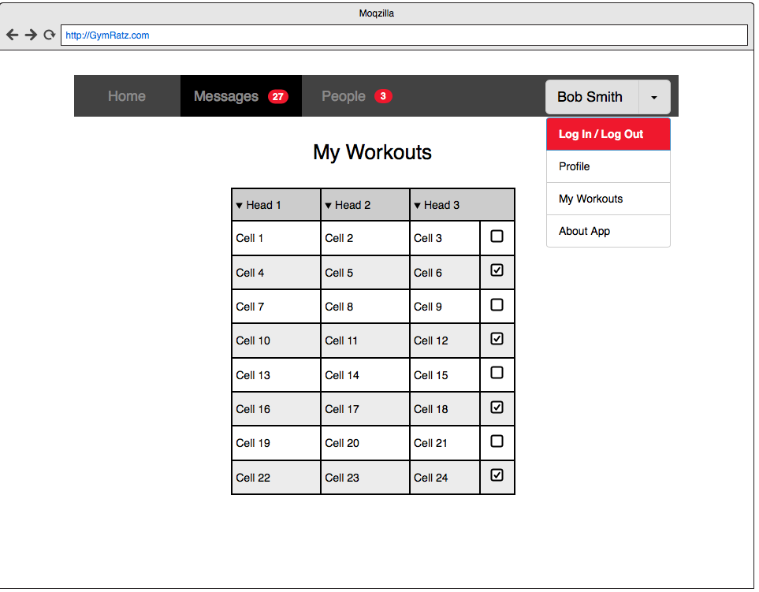

Part III:

